CALL proc_view_noratecourses('179186');

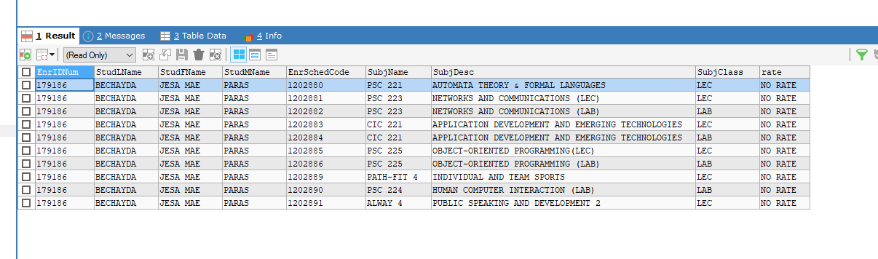

CALL proc_viewrating_perstudent('179186',202,'1202887');

